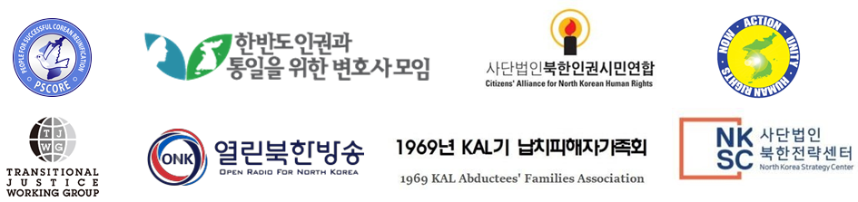
The world’s largest Mass Games, a horrible display of child exploitation, is once again being used by the North Korean government to bring in foreign currency revenue.

The 5th of May of each year is defined as Children’s Day in the Republic of Korea in order to uphold the values of love and protection towards children, enabling them to develop into righteous, bright, wise and strong individuals. Likewise, North Korea correspondingly observes International Children’s Day and the day of establishment of the Youth Guard on the 1st and 6th of June respectively, and this demonstrates the importance both South and North place on children. Kim Jong-un even attended the event celebrating the day of establishment of the Youth Guard in 2012 and 2013 as a display of his affection towards children.
However, the situation of children’s rights in North Korea is far dire beyond expectations. The reality is that the government operates a system of child exploitation and children do not receive the most basic level of protection they deserve from their country.

As famous as the North Korean Mass Games are for their sheer scale, it is also a reflection of the vastness of the violation of human rights involved. The seriousness of the violation of rights that children suffer during their months of practice is confirmed through the report of the UN HRC’s Commission of Inquiry on Human Rights in the DPRK as well as various media reports and testimonies.

The UN HRC’s report states:
“The Mass Games have become a major source of foreign currency revenue for the DPRK. They attract large numbers of tourists, who are often unaware of the human rights violations endured by children, who are compelled to participate. Training will often last an entire year, including 4-6 months during which the participants train all day at the expense of their schooling. Training practice is extremely tiring and demanding. Children who do not perfect their performances are subjected to physical punishment and additional evening training.”

Testimonies of North Korean defectors support the allegations:
“The Mass Games were the one time when I felt disadvantaged for having been born in Pyongyang. Children need to participate starting from elementary school. There were Mass Games even before ‘Arirang’. ‘Baekyungdae’ comprised around 50,000 children and they were the ones holding up cards for the synchronized background image changes. There are children (elementary students) who die from practicing in the heat in the middle of summer. When I was in elementary school, one of the students from my grade died and one of my friends started seeing blood in his urine because the circumstances were that dire. The toughest aspect was practicing non-stop in the sun and also the never-ending repetitions we had to do in order to perfect our timing. A minimum of 6 months practice was required and we practiced exactly 1 year for the ‘Arirang’.” - Born in the mid-80’s, Pyongyang

North Korea’s Mass Games were recognized by the Guinness World Records in 2007 as the world’s largest gymnastic display with the most participants in a single performance. In other words, as far as human rights violations go it is internationally and officially recognized to be the largest in scale for its type.

North Korea has made official the continuation of the Mass Games in 2019 and word from Pyongyang is that children have started training accordingly. Preparations to attract tourists for the September performances are also underway through various travel agencies. Even if recent talks between both Korea’s as well as efforts to denuclearize and normalize North Korea through US-NK summits were to be successful, what use would it all be if the exploitation of children and violation of their rights, the future generation, were to continue?

Our group of human rights organizations strongly condemn the practice of generating foreign currency revenues off the backs of North Korean citizens, as well as their inhumane situation of being exploited without compensation. Furthermore, we strongly condemn the practice of forcing North Korean children to participate in the Mass Games and urge that not a single child be exploited any further. Also, any foreigners or politicians who visit North Korea must not watch the performances and we recommend them to strongly request the North Korean government to protect children’s rights.

Citizens’ Alliance for North Korean Human Rights | 북한인권시민연합
North Korea Strategy Center (NKSC) | 북한전략센터
1969 KAL Abductees’ Families Association | 1969년 KAL기 납치피해자가족회
Now Action & Unity for Human Rights (NAUH) | 나우
Open Radio for North Korea (ONK) | 열린북한방송
Transitional Justice Working Group (TJWG) | 전환기정의워킹그룹
Lawyers for Human Rights and Unification of Korea | 한반도 인권과 통일을 위한 변호사모임
People for Successful COrean REunification (PSCORE) | 성공적인 통일을 만들어가는 사람들

Children’s Welfare Law Article 6 (Children’s Day and Children’s Week)
2014 UN HRC Report of the detailed findings of the commission of inquiry on human rights in the DPRK, paragraph 174
Child Labor within North Korea 2018, 149p, People for Successful COrean REunification
Guinness World Records, ‘Largest gymnastic display’, 14 August 2007 http://www.guinnessworldrecords.com/world-records/largest-gymnastic-display
NK News, Mass Games training drills observed in Pyongyang, photos show, April 20th https://www.nknews.org/2019/04/mass-games-training-drills-observed-in-pyongyang-photos-show/?fbclid=IwAR3tmFNWb0qaVczfIGVySlG-frNeXjJobxYWCVaLqZ6pDhmS1c9JMHSFa9s
https://www.visitthedprk.org/mass-games-2019-tours

